INSTITUCIÓN EDUCATIVA NORMAL SUPERIOR DE ENVIGADO

NOMBRE: __________________________________________________

GRADO:

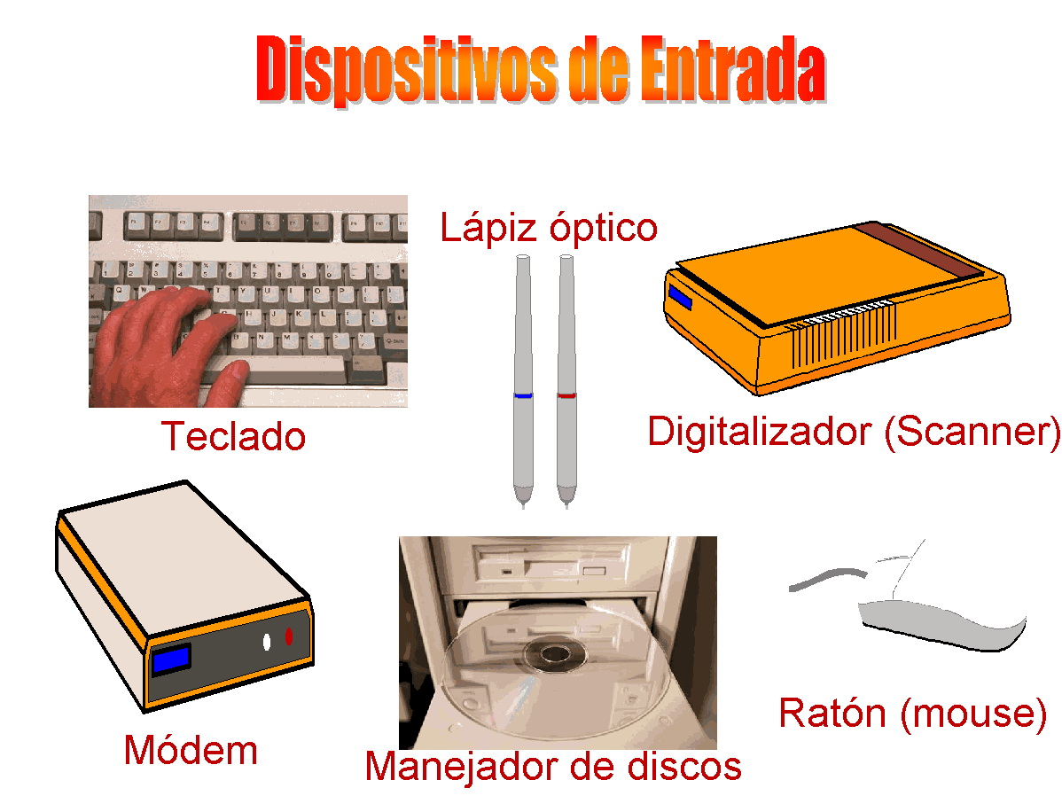

**¿Por qué estos artefactos son Dispositivos de Entrada?**

**___________________________________________________________________________________________________________________________________________________________________________________________________________________________________________________________________________________________________________________________**

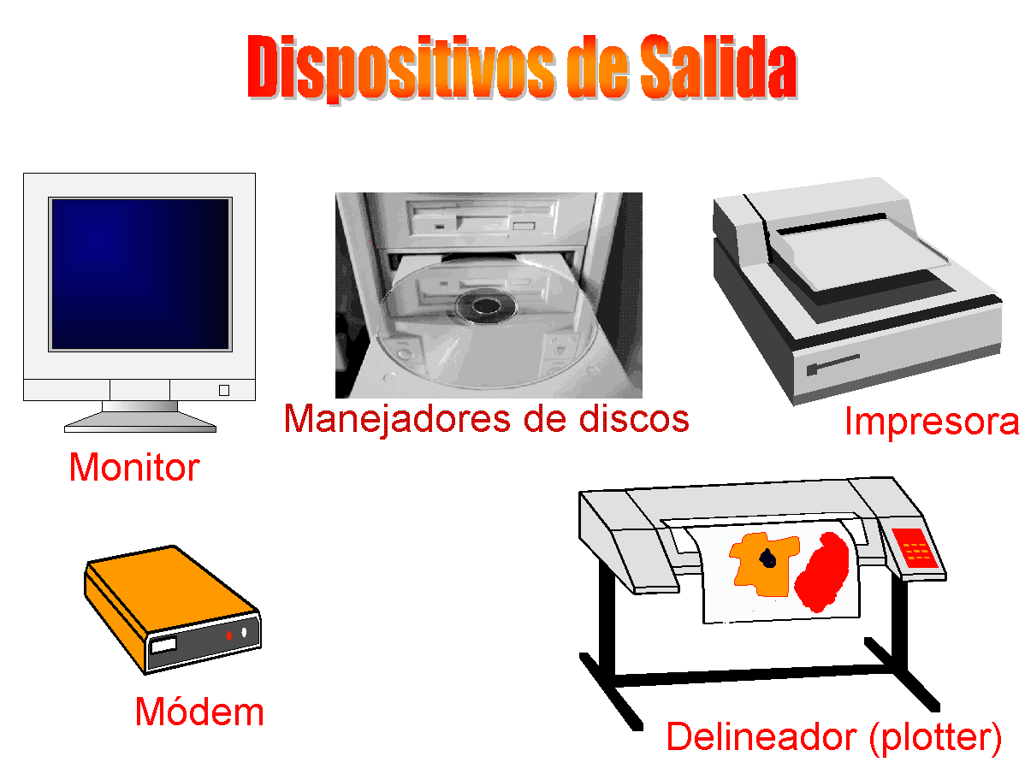**¿Por qué estos artefactos son Dispositivos de Salida?**

**___________________________________________________________________________________________________________________________________________________________________________________________________________________________________________________________________________________________________________________________**